MEDIA STATEMENT FOR IMMEDIATE RELEASE WITHOUT EMBARGO
ISSUED BY THE DRAKENSBERG BOYS CHOIR SCHOOL
FINAL FOR SOUTH AFRICAN DISTRIBUTION

DRAKENSBERG BOYS CHOIR TAKES ITS MINISTRY OF MUSIC ACROSS SOUTHERN AFRICA

10 SEPTEMBER 2026, CENTRAL DRAKENSBERG, SOUTH AFRICA – This September, the internationally acclaimed Drakensberg Boys Choir (Drakies) will take its distinctive sound across Southern Africa as it embarks on its Drakies Southern African Tour 2026 through Botswana, Zambia and Zimbabwe. Running from 26 September to 5 October 2026, the regional tour will take the Drakies from Gaborone and Lusaka to Harare, Bulawayo and Victoria Falls, bringing together music, cultural exchange and some of Southern Africa’s most remarkable destinations.

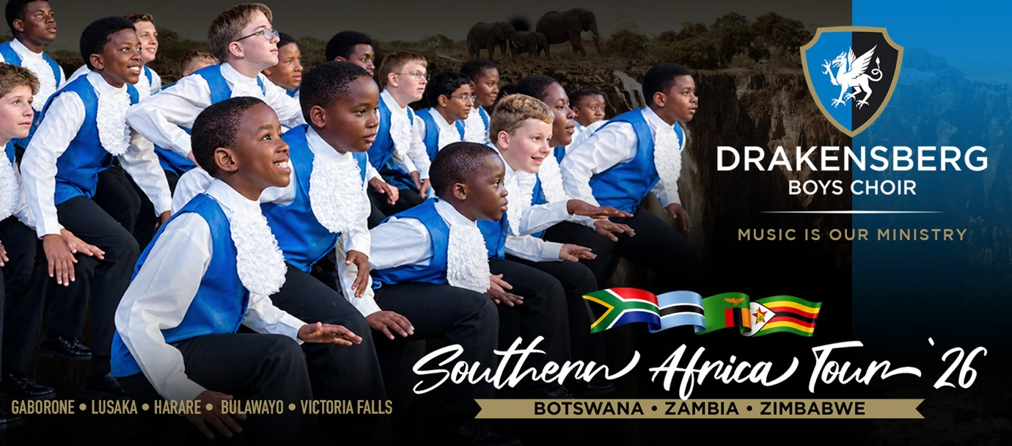

The Drakies Southern African Tour 2026 begins in Gaborone, Botswana, with a performance scheduled for Saturday, 26 September. The Choir then travels to Lusaka, Zambia, where it is scheduled to perform at Lusaka International Community School on Sunday, 27 September. Concert times for these two performances are still to be confirmed. From Zambia, the Choir heads to Zimbabwe for the longest leg of the tour with performances in Harare, Bulawayo and Victoria Falls.

Southern African audiences can look forward to the versatility for which the Drakensberg Boys Choir is internationally recognised, blending classical masterworks and contemporary repertoire with a vibrant indigenous South African programme that brings together rhythm, language, movement and choral discipline.

“Touring within southern Africa is incredibly meaningful to us,” says Hendrik Bekker, Executive Head of Drakensberg Boys Choir School (DBCS). “Across our region, we share deep choral traditions rooted in community, storytelling and rhythm. This tour celebrates that shared heritage while inspiring hope through youthful voices.”

Music is our Ministry across Southern Africa

At the heart of the tour is the theme Hope, Heritage, Harmony, reflecting both the Drakies’ identity and the connections that music can create across borders. “As one of Africa’s most recognised boys’ choirs, and the only specialist boys’ choir of its kind on the continent, the Drakensberg Boys’ Choir has a unique responsibility to contribute to the development and celebration of choral music across Africa. Visiting Zimbabwe, Zambia and Botswana allows our choristers to experience different cultural environments, sharing the musical traditions that form part of the Choir’s own identity and living our motto of Music is our Ministry,” says Jacques Linde, Head of Choral Activity.

The repertoire has been carefully curated to showcase the breadth of the Choir’s musical ability. Classical and contemporary works will sit alongside an indigenous South African programme that forms the heart of the performance, creating a musical experience firmly rooted in tradition yet fresh, energetic and relevant.

The Drakies Southern African Tour 2026 provides an important opportunity for cultural and musical exchange. Audiences can expect a programme that reflects the breadth of the Choir’s repertoire, moving between Western classical and sacred repertoire, contemporary works, African choral music, South African indigenous repertoire, and popular selections. This diversity is central to our artistic identity: we want our boys to understand that excellence in choral music is not confined to one musical tradition, but can be found across cultures, languages and communities.

Under Linde’s direction, himself a Drakies alumnus, the 2026 season focuses on cultivating a healthy, unified and artistically sincere sound, ensuring that the next generation continues to uphold the Choir’s international standing.

A journey through Southern Africa

“The Drakies Southern African Tour 2026 represents an important opportunity for the Choir to strengthen its artistic and educational presence beyond South Africa and to engage meaningfully with neighbouring countries across the Southern African region,” says Linde.

- 26 September, Cresta Lodge, Gaberone
- 27 September, Lusaka International Community School, Roma, Lusaka
- 30 September, Odeon Hall, Alexandra Park, Harare
- 03 October, Robert Sibson Hall, Hillside Road, Bulawayo
- 05 October, Victoria Falls Primary School, Victoria Falls

The programme also includes a visit to the Peterhouse Group of Schools and Gosho Park on 29 September, where an informal community performance is planned, before the Choir returns to Harare for two public concerts at the Odeon Hall at Hellenic School.

The journey then continues through Bulawayo to Victoria Falls, allowing the choristers not only to perform, but also to experience some of Zimbabwe’s extraordinary natural and cultural heritage, including Matobo Hills and Victoria Falls.

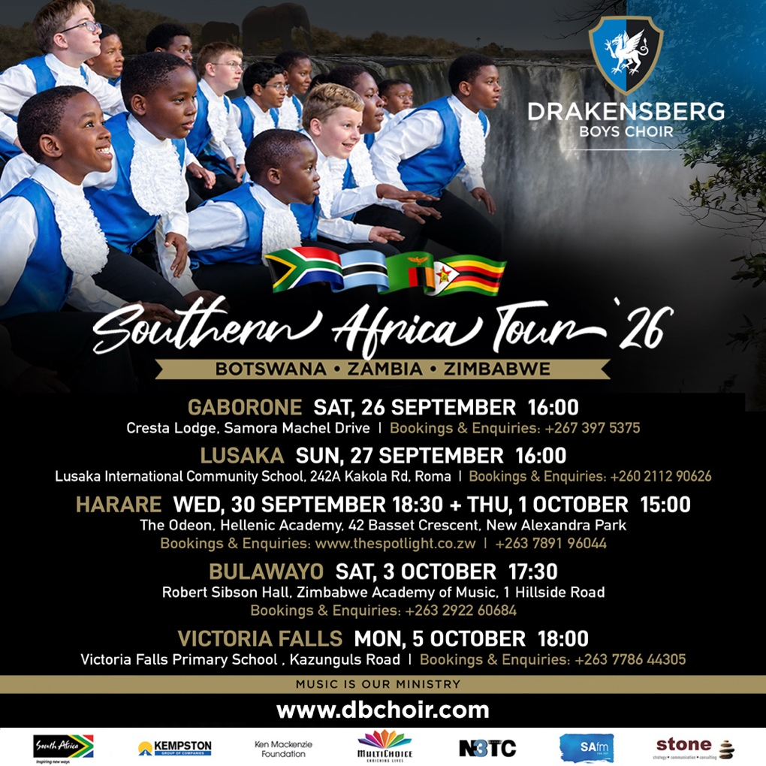

With their signature precision, vibrant choreography and unmistakable stage presence, the Drakensberg Boys Choir promises audiences across the three countries a concert experience that celebrates both musical excellence and a shared Southern African identity.

The tour reflects the Choir’s belief that music can transcend borders, build relationships and connect young people across cultures. Through this journey, our boys will not only perform for new audiences, but will also learn from the people and cultures they encounter, returning home with a deeper understanding of the continent they are privileged to represent.

Strengthening regional cultural exchange

Southern Africa has a rich musical tradition, particularly within choral music, where community, rhythm and storytelling play a central role. The indigenous South African repertoire performed during the tour celebrates these connections while showcasing the diversity of languages, sounds and expressions that have become a defining part of DBCS performances.

For the choristers themselves, touring is also an important part of their education. Beyond performing for new audiences, the journey gives the boys an opportunity to encounter different communities, cultures and landscapes across the region. “Encounters with other young people, musicians, schools and communities will broaden our boys’ understanding of Southern Africa and reinforce the idea that music can serve as a powerful means of communication across cultural and national boundaries,” adds Bekker.

“We seek not only to perform, but to connect, reminding audiences that harmony begins with listening, collaboration and respect,” adds Bekker. “Through hope, we build the future. Music is our ministry, and it remains one of the most powerful bridges across borders.”

“The experience will also develop qualities such as independence, adaptability, teamwork and responsibility as the boys represent their Choir, School and country abroad. Each year, the choir is renewed by new voices and personalities. While the faces change, the pursuit remains constant: disciplined artistry, musical integrity and meaningful cultural expression,” Bekker adds. “Thus, an important dimension of this tour is the opportunity it creates for future recruitment and continental representation,” he says.

The Drakensberg Boys’ Choir is uniquely positioned to welcome talented young singers from across Africa into its community. We would like the Choir to increasingly reflect the diversity of the continent it represents. Engaging with schools, families and musical communities in Zimbabwe, Zambia and Botswana can therefore open meaningful pathways for talented boys from these countries to experience the Drakensberg Boys’ Choir.

“As the only specialist boys’ choir of its kind on the African continent, the Drakensberg Boys’ Choir has a unique role to play in developing and celebrating choral music in Africa. The tour will therefore also serve as an opportunity to build relationships with schools, musicians, and families in the region and explore future recruitment opportunities. Welcoming talented boys from across Africa into the Choir would strengthen its identity as a truly pan-African institution and provide young singers with the opportunity to receive a world-class musical and educational experience,” says Linde.

For a young boy from elsewhere in Africa to join the Choir, live and learn in the Drakensberg, perform on international stages and become part of a world-renowned musical institution is a powerful proposition. It creates opportunities not only for the individual chorister, but also for the Choir to become an increasingly pan-African musical institution.

“The Southern Africa Tour is more than an opportunity to take the Drakensberg Boys’ Choir to neighbouring countries. It is an opportunity to bring the Choir closer to the continent it represents, to establish relationships that can develop over many years, and to encourage young African musicians to see the Drakensberg Boys’ Choir as a place where their musical potential can be nurtured,” explains Linde.

Ultimately, the vision is for the Drakensberg Boys' Choir to continue building bridges between South Africa and the wider African continent through the shared language of choral music. The 2026 Southern Africa Tour is an important step towards that vision.

More than a music school

Founded in 1967, the Drakensberg Boys Choir School prepares boys for life and leadership through excellence in music, academics, sport and social enrichment in a Christian environment. The School remains the only institution on the African continent where choral singing forms part of the daily curriculum, enabling sustained musical training and artistic growth.

For decades, the Drakies has performed on prestigious stages around the world, earning a reputation for versatility, precision and vibrant stage presence. The integration of Western classical discipline and indigenous South African musical heritage has become a defining hallmark of the ensemble.

The 2026 Heritage Tour is made possible through the valued support of the Choir’s anchor partners: Brand South Africa, Kempston Group, the Ken MacKenzie Foundation, MultiChoice, N3TC, SAfm and Stone. Their investment in youth and the arts continues to strengthen cultural collaboration across Southern Africa.

FIN
(1393 words)

EDITORS' NOTES

Media release issued by Stone on behalf of Drakensberg Boys Choir School

Visit the DBCS website to purchase tickets and view the concert programme: http://www.dbchoir.com

For media enquiries, interview requests or in-studio or recorded media appearances, contact:
Kgotso Chauke or Taonga Chiwala of the Drakensberg Boys Choir School media team at Stone
Email: media@stone.consulting
Phone: +27 62 870 2294 / +27 11 447 0168

Alternative media contact and further marketing information or enrolment of boys at the school:
Helga Cato, Marketing Coordinator of Drakensberg Boys Choir School
Email: hcato@dbchoir.com / Phone: +27 83 232 1229
Recruitment link: https://dbchoir.com/enrolment

Contribute to the DBCS bursary fund:
Lizél Potgieter, Accountant of Drakensberg Boys Choir School
Email: accountant@dbchoir.com / Phone: +27 36 468 1012
Donation link: https://dbchoir.com/support-us

Book the Choir for a performance:
Elanza Joubert, Tours and Operations Manager of Drakensberg Boys Choir School
Email: tours@dbchoir.com / Phone: +27 36 468 1012

More helpful website links for media reference:

- Please visit the Drakensberg Boys Choir School website at www.dbchoir.com to learn how Drakensberg Boys Choir School builds character and moulds and develops boys to harness the gift of music to bring hope, impact, and positive change to South Africa and beyond. DBCS offers a unique, complete and diverse schooling experience that will forever change every Drakie boy's life by being part of this centre of excellence. DBCS builds resilience, grows relationships, and fosters global ambassadors with music as the tool for God’s glory.
- Please visit the Drakies Facebook page for views of sold-out performances and Drakie life activity at this unique boys' middle school in the majestic Drakensberg mountains – https://www.facebook.com/dbchoir
- The photo pages on the Drakies website and Facebook page gives a good view of the diversity, life and extraordinary talent of the boys at Drakensberg Boys Choir School – https://dbchoir.com/gallery and https://www.facebook.com/dbchoir/photos
- Visit these video links for a glimpse of the world-renowned Choir's international and local choral work, both in the classical and distinctly African genres: https://www.dbchoir.com/gallery (scroll down on the page for videos), https://www.youtube.com/user/DBCHOIR, https://youtu.be/C521O4XHO_I, and https://www.facebook.com/dbchoir/videos/934329527988775/

